**INDIA'S AGRICULTURAL CROP PRODUCTION ANALYSIS 1997-2021**

|  |  |  |
| --- | --- | --- |
| **Student Name** | **Team** | **Student NM id** |
| KALIMA SIRIN M | Team Leader | E3DBC53EF30D59A935E4D53E7790E2C6 |
| BHARATHY B | Team Member | DE65DF32D8BB1FD8A61486E07401092A |
| JEYA LAKSHMI M | Team Member | 7BBDD5D1DF832E186694BAE3774DDFB0 |
| NIRMALA A | Team Member | BAC090822B0A99F920F4139EF6F8651D |
| SIVA SATHYA M | Team Member | 47292C4AE74082CA7C44D5D3EB5EE053 |
| VALARMATHI J | Team Member | 9112B57A155D304B2A7461D16790F231 |

**Content:**

1. **Introduction**
   1. **Overview**
   2. **Purpose**
2. **Problem Definition & Design Thinking**

**2.1 Empathy Map**

**2.2 Brainstroming Map**

**3. Result**

**4. Advantages & Disadvantages**

**5. Applications**

**6. Conclusion**

**7. Future Scope**

**8. Appendix**

**INDIA'S AGRICULTURAL CROP PRODUCTION ANALYSIS 1997-2021**

**1. INDRODUCTION:**

**1.1. OVERVIEW:**

India's agriulture is composead of many crops, with the foremost food staples being rice and wheat. Indian farmers also grow pulses, potatoes, sugarcane, oilseeds, and such non-food items as cotton, tea, coffeem rubber, and jute.Despite the overwhiming size of the agricultural sector, however, yield per hecter of crops in India are generally low compared to interntional standards. Improper water management is another problem affecting India's agriculture. At a time of increasing water shortages and environmental crises, for example, the rice crop in India is allowcated disproportionality high amount of water. It is estimated that as much as one-fifth of the total agricultural output is lost due to inefficiencies in hresting, transport, and storaage of Government -subsidized crops. So lets us analysis more about the crop cultivtion, cost invested, seasons for cultivation.

**1.2 PURPOSE**

This project is used to we can know the agricultural development and exchange and decline..,etc of India. If you do agriculture through this project we can get good result. It possible to know which crop yield more in each season. Through this project we can achieve about the agricultural practises in India.

**2. PROBLEM DEFINITION & DESIGN THINKING:**

**Empathy Map**

An empathy map is a template that organizes a user’s behaviors and feelings to create a sense of empathy between the user and your team.  The empathy map represents a principal user and helps teams understand their motivations, concerns, and experience. Empathy mapping is a simple yet effective [workshop](https://frescopad.com/virtual-workshop-definition/) that can be conducted with various users in mind, anywhere from stakeholders, individual use cases, or entire teams of people. Many teams, such as design teams, sales, product development, and customer service, can conduct it.  Essentially, an empathy mapping exercise is a practice that seeks to get inside the head of the customer as they interact with your product/service. While the main importance of an empathy map is creating empathy between you and the user, some other important facets of using one offer different benefits to your team. Creating an empathy map considers many factors in relation to the customer’s overall experience.  These could be the problems they handle, how they use the product/service within a larger team, and who experience the brunt of the problem.  These details are essential to creating a holistic view of their experience because they illuminate the problem in your team’s mind. This is equally as important and helps build an overall understanding of how users interact with your product/service. Empathy mapping is an important tool used in marketing, product development, and user experience design to identify and solve individuals’ or target audiences’ requirements, motivations, and experiences. Empathy mapping can be applied to various design thinking activities, including user research, brainstorming, and prototyping. It’s critical that users, on some level, enjoy using your product/service. They will eventually leave and use something else if they don’t enjoy it.  As a business manager, this should be avoided at all costs, and the easiest way to avoid turnover is by ensuring a positive customer experience. Empathy maps are the easiest way to break down your customer experience and highlight the areas you can target for improvement. By incorporating [surveys](https://www.questionpro.com/blog/surveys/) and lines of direct feedback, they serve almost as a usability test and a journey map. Not only can you realize where their experience is lacking, but by putting yourself in the user’s shoes, you gain a better perspective of how your product functions in general. By understanding this, you can find holes and flaws you didn’t know existed and take your product/service to another level. During an empathy mapping session, participants can interact to develop those flaws in an empathy map.

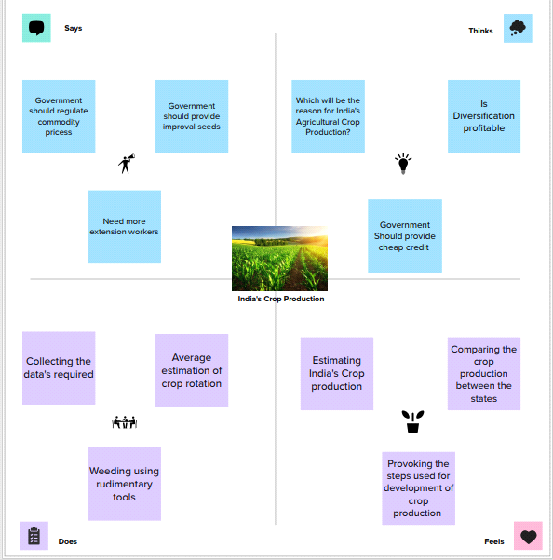

**2.2. IDEATION & BRAINSTORMING MAP:**

When brainstorming, or attempting to see a particular topic from all angles, linear tools — like lists — aren’t always the best solution. In fact, thinking this way can hinder creativity. The solution? A mind map. This organizational structure allows you to explore a central topic on a deep level through associated ideas and concepts which branch off from the center organically. On paper, a mind map resembles a tree, with your central topic at the center of the page. From there, lines (or *branches*) are drawn to sub-topics represented by keywords.  From here, you can go another level down with even smaller branches sprouting off into other related areas. With each new level, you move further away from obvious or surface level ideas and thoughts — that’s why a mind map can help you *fully* explore a topic, beyond face value.

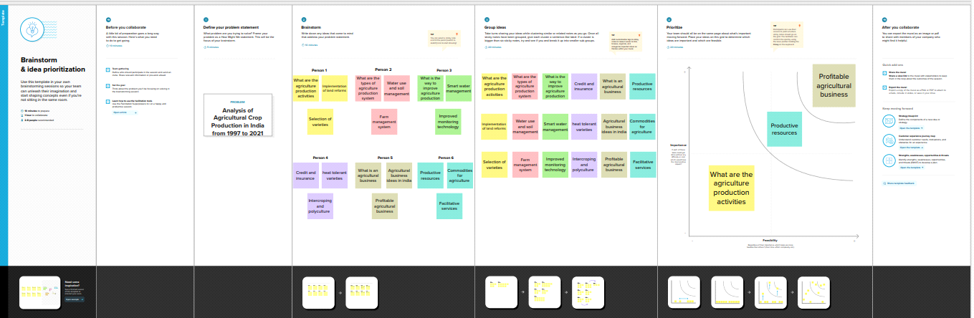

**3. RESULT: ACTIVITY 1.1.**

**STATEWISE AGRICULTURAL LAND**

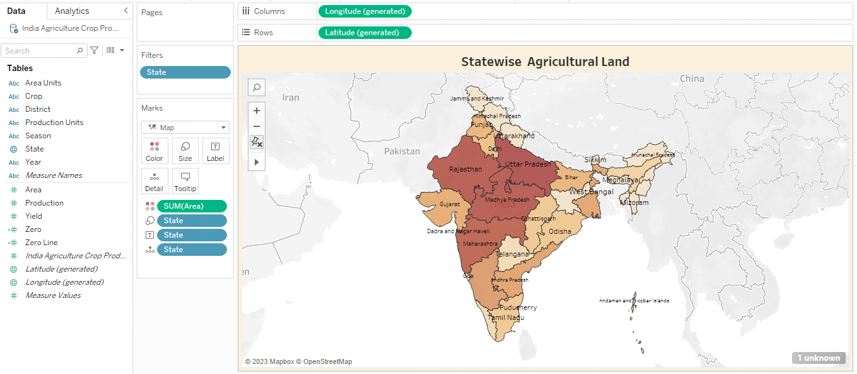

**ACTIVITY 1.2.**

**AREA Vs PRODUCTION**

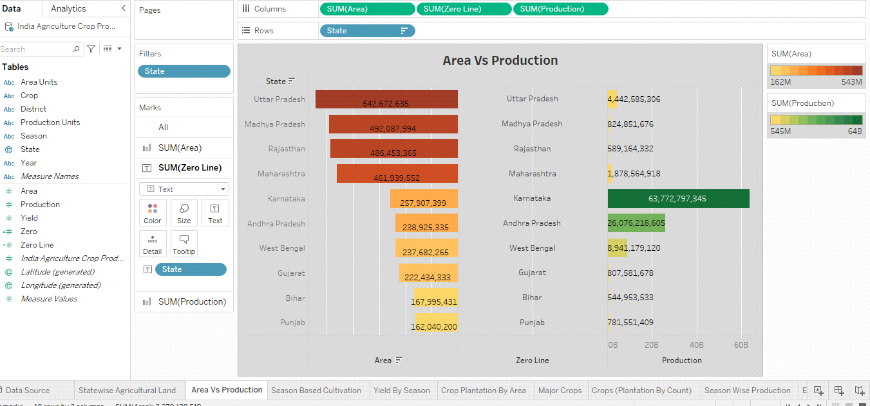

**ACTIVITY 1.3**

**SEASON BASED CULTIVATION**

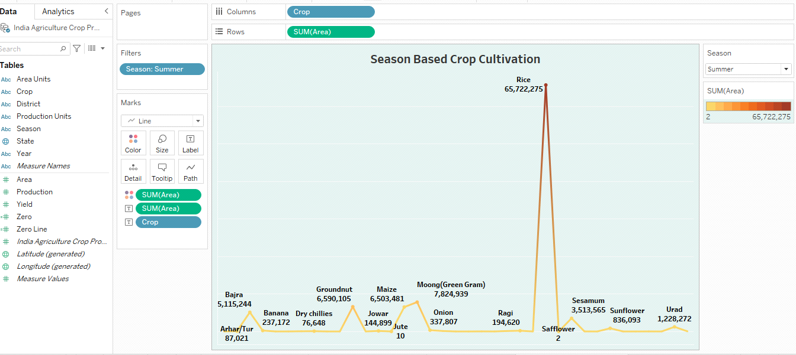

**ACTIVITY 1.4.**

**YIELD BY SEASON**

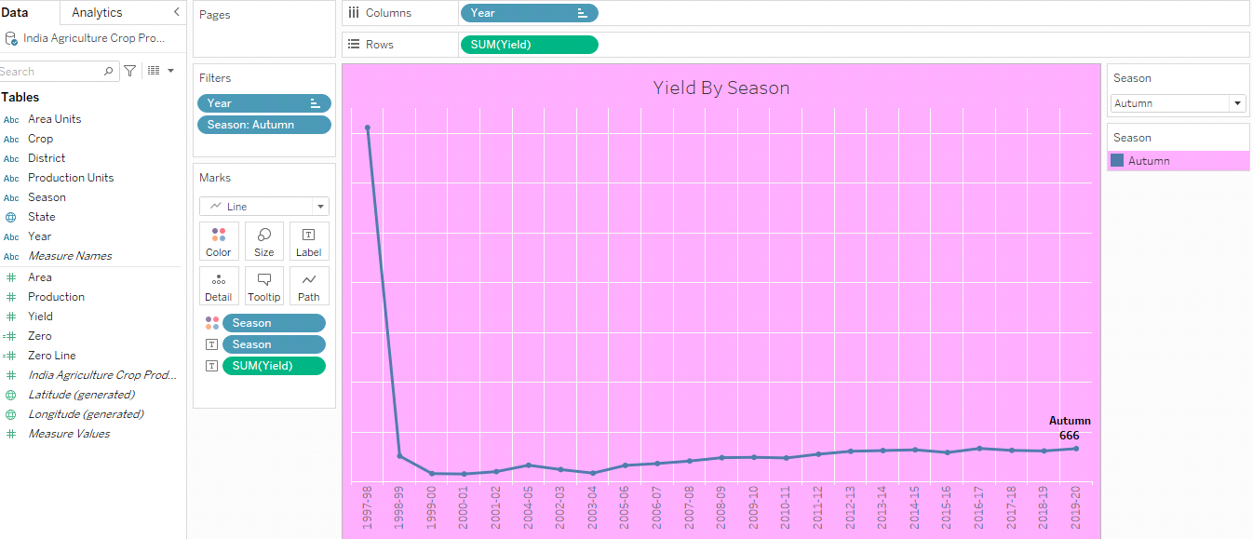

**ACTIVITY 1.5.**

**CROP PLANTATION BY AREA**

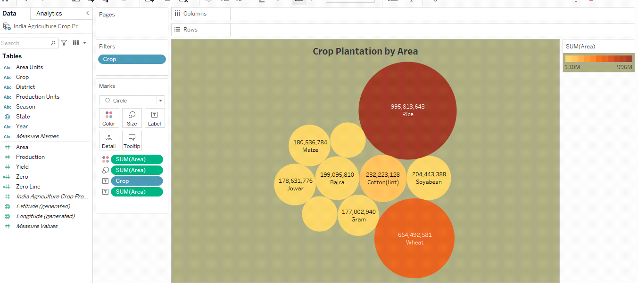

**ACTIVITY1.6:**

**MAJOR CROPS GROWTH YOY**

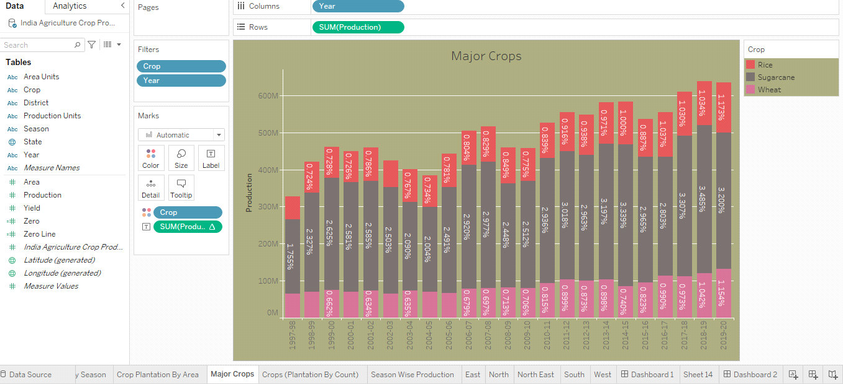

**ACTIVITY 1.7:**

**CROPS(PLANTATION BY COUNT)**

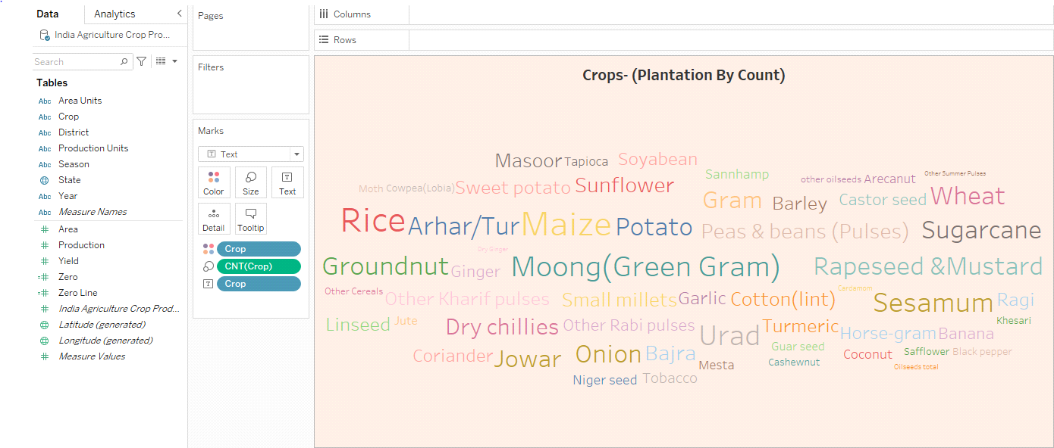

**ACTIVITY 1.8:**

**SEASON WISE PRODUCTION**

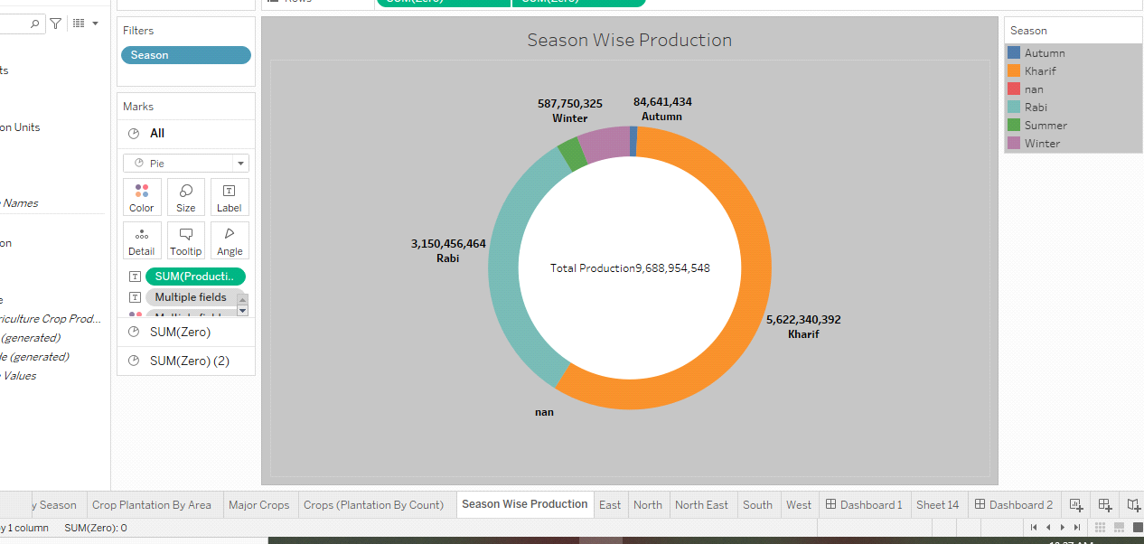

**ACTIVITY 1.9:**

**kpi's EAST:**

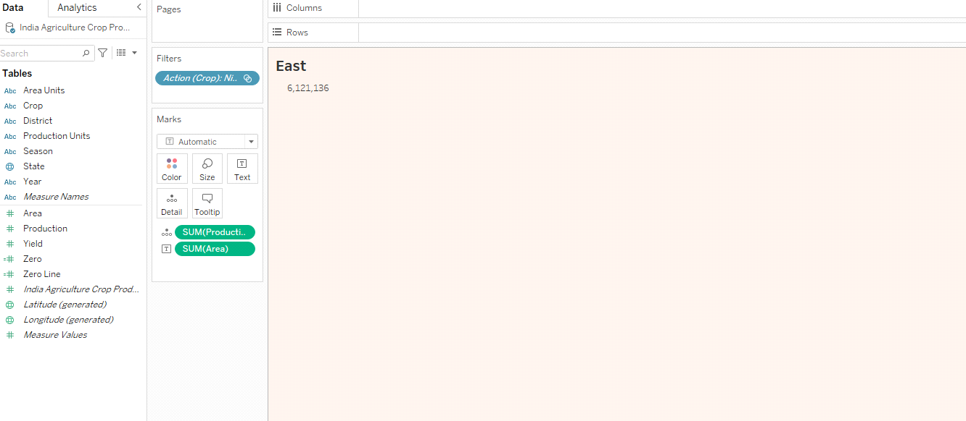

**NORTH:**

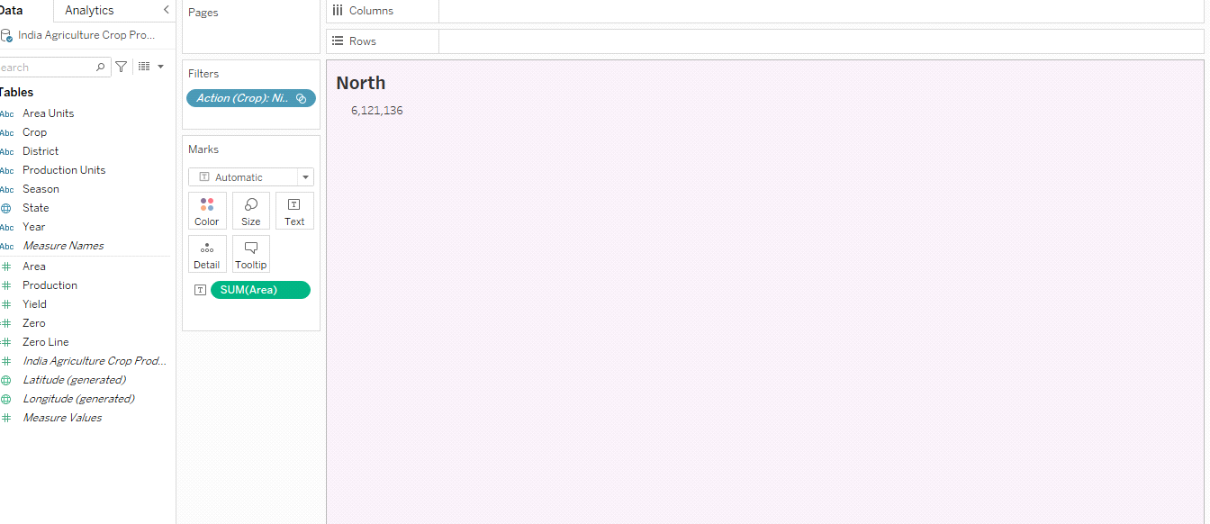

**NORTH EAST:**

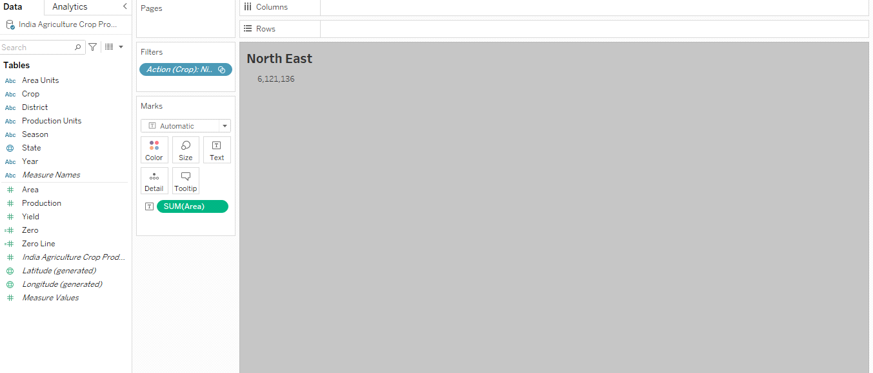

**SOUTH:**

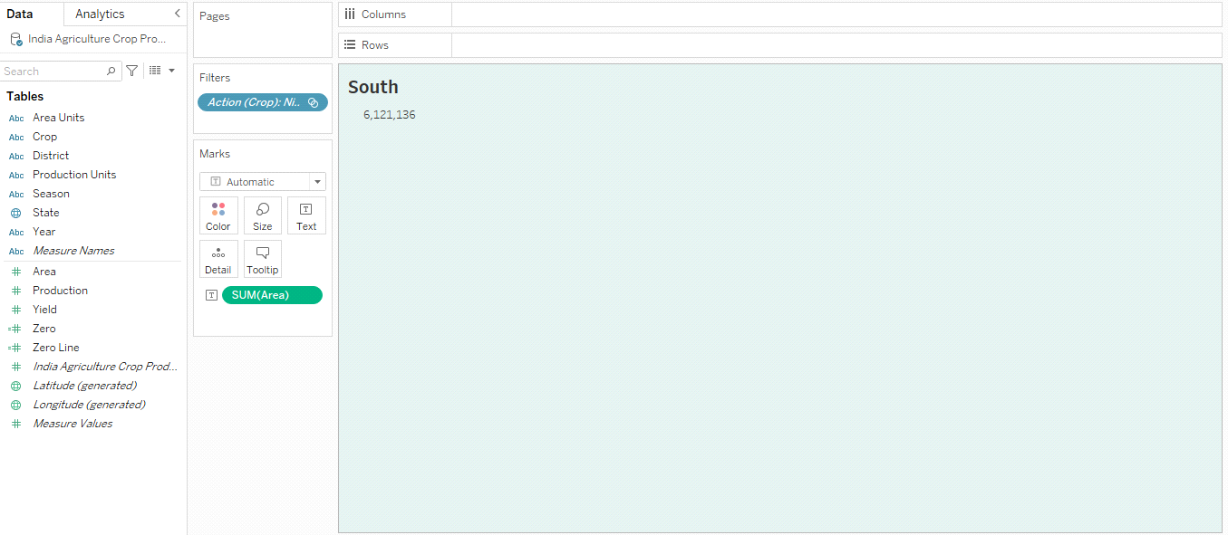

**WEST:**

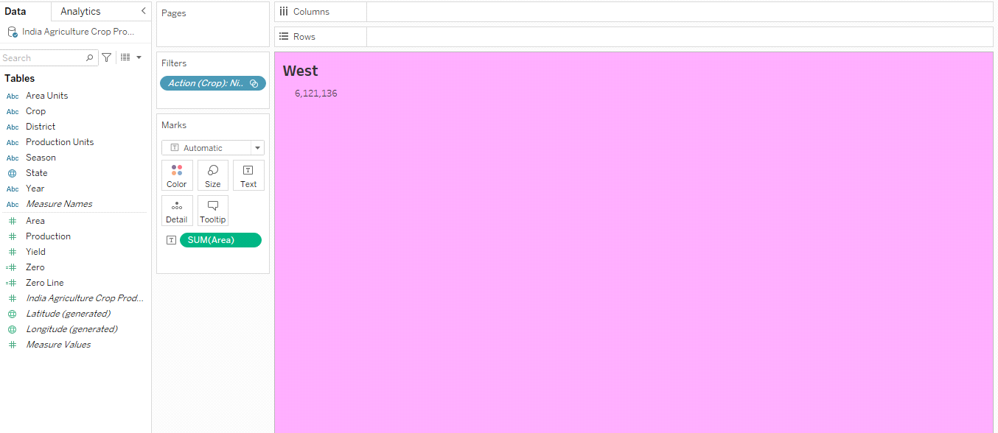

**DASHBOARD 1:**

**AREA IN ACRES REGION-WISE**

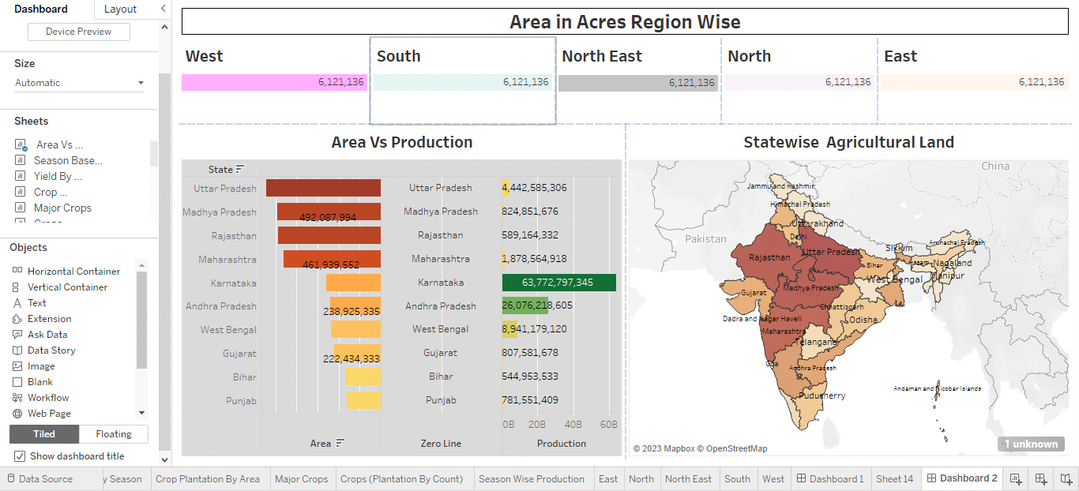

**DASHBOARD 2:**

**PRODUCTION IN TONNES REGION-WISE**

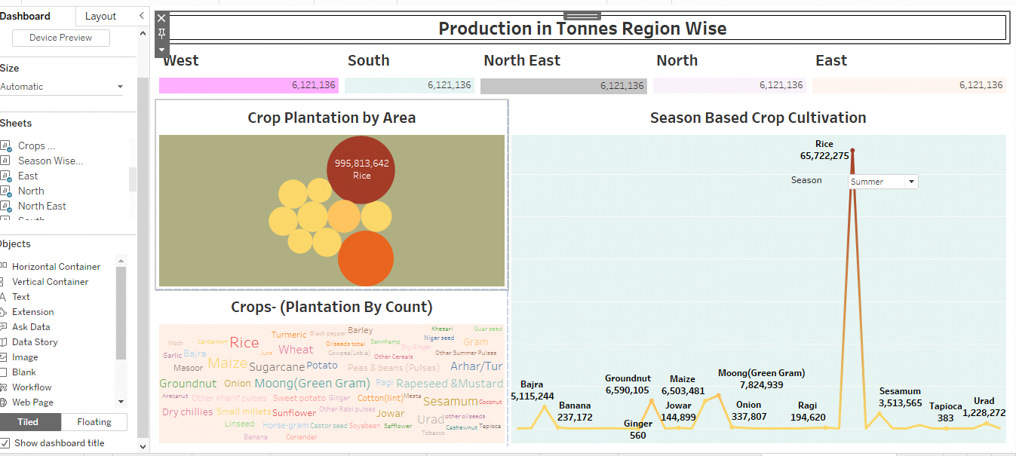

**DASHBOARD 3:**

**SEASONWISE PRODUCTION ACRES SEASON &**

**CROPS**

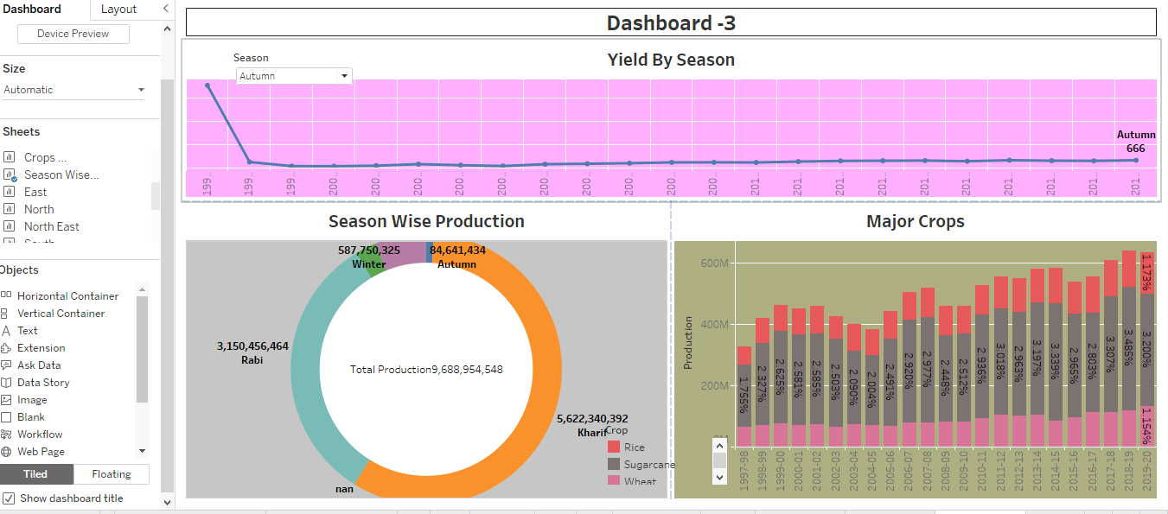

**STORY:**

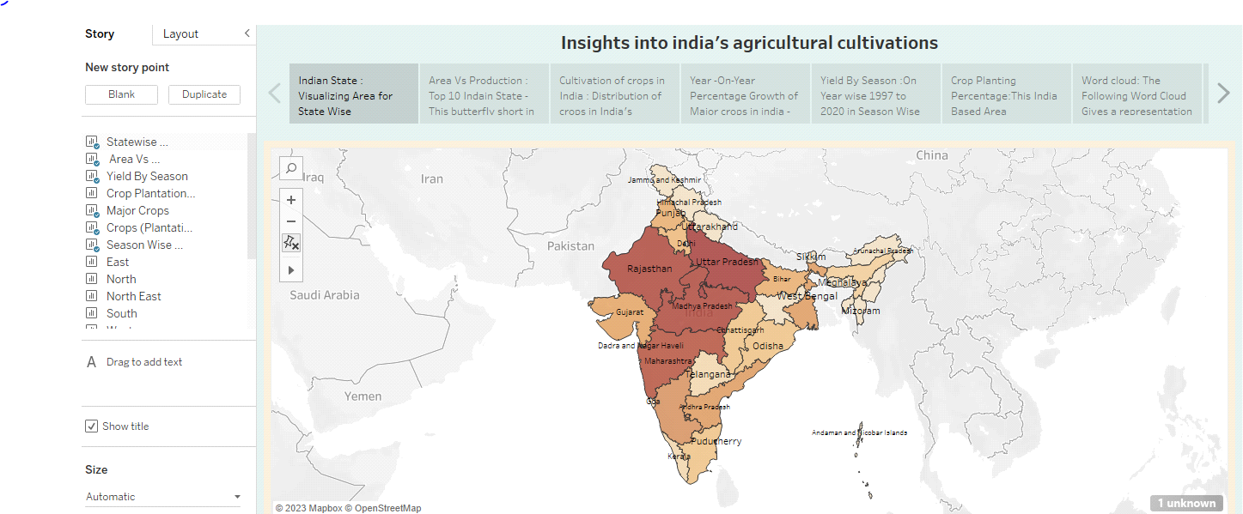

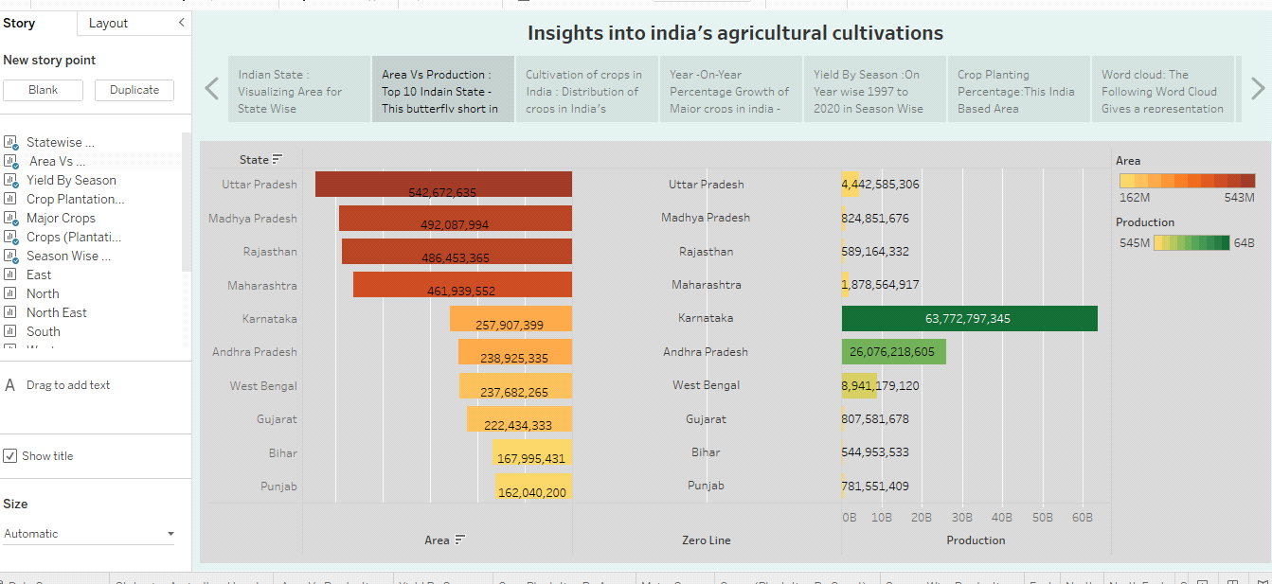

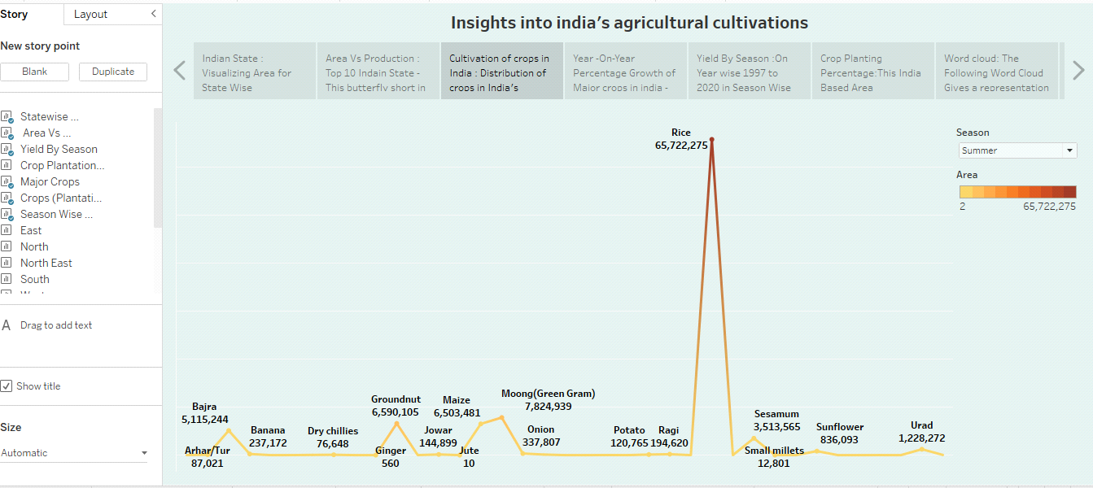

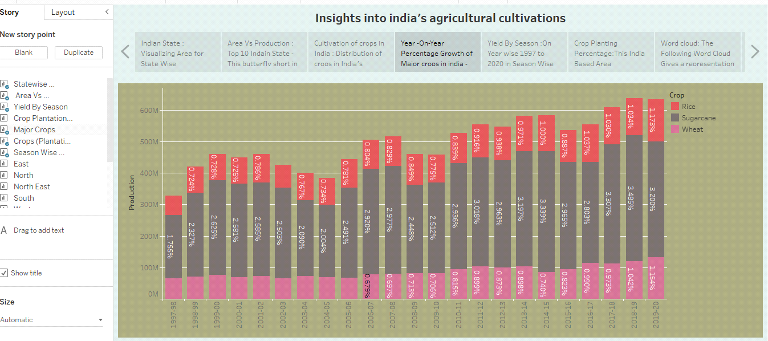

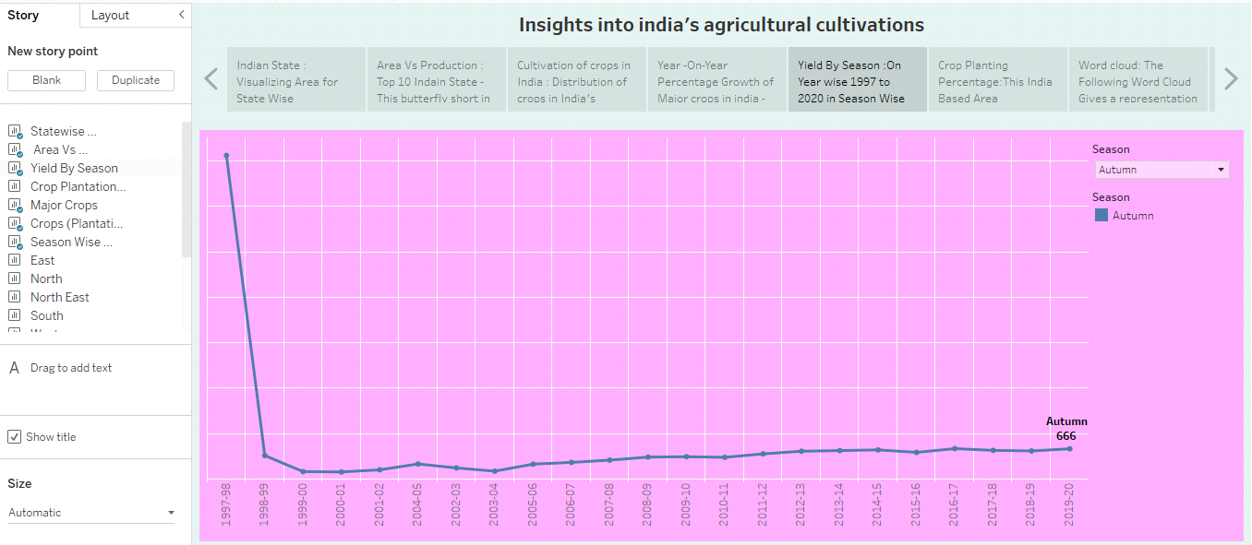

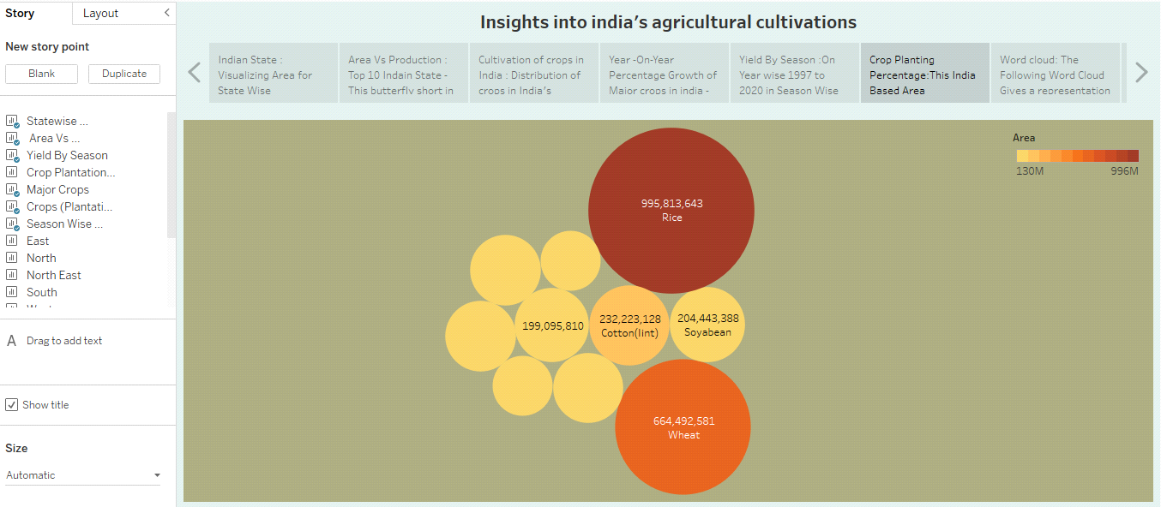

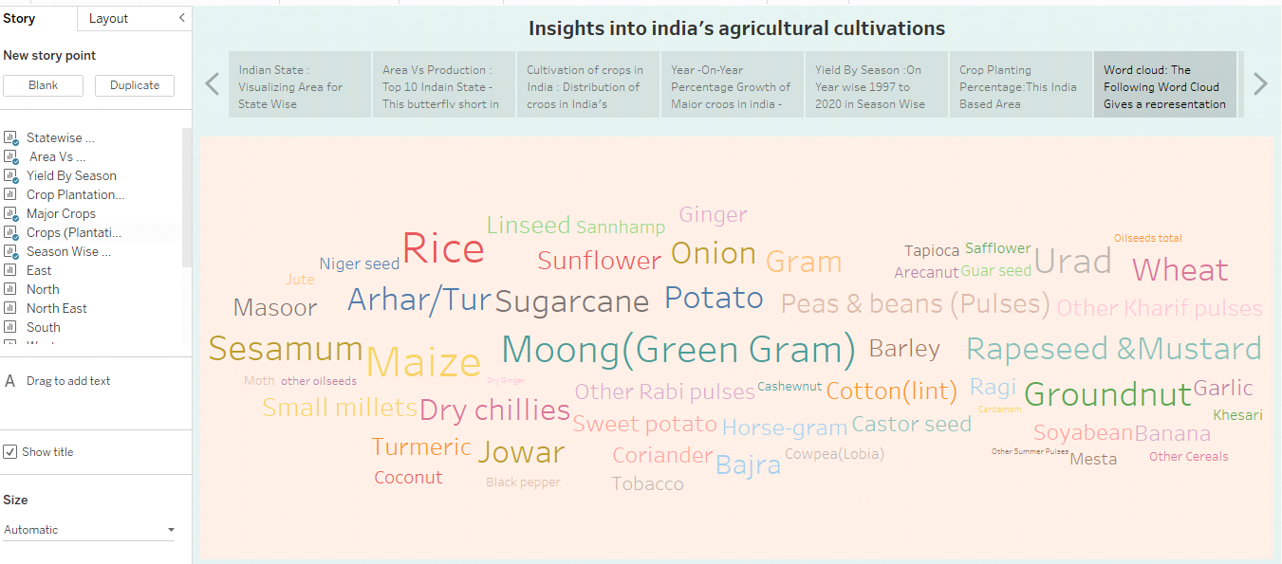

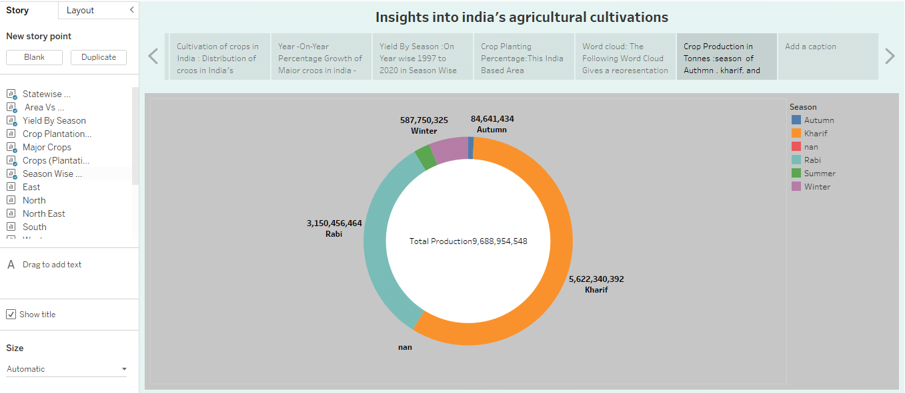

**ADVANTAGES:**

1. This project plays an important role in agricutural maintanance.

2. We know the various agricultural plan.

3. Agriculture can get good result through this project.

4. This project plays an important role for future agricultural

development.

5. This project inculcates a passion for the future young generations of

farmers.

6. This project used to we can learn and know about the agricultural

practises in India.

**DISADVANTAGES:**

1. This project only provides a limited amount of information about

agricultural development.

2. It is not possible to know fully which season the crop yield will be

good.

3. Learn about low-volume crop varieties.

**APPLICATONS:**

1. It is possible to know which crop seeds are sown in each season of each year in India and how crops yields rise and fall in each year.

2. Cultivating, characterizing or modefiying soil; producing, growing, improving, producting, treating or modefying crops or forests products; rising, harvesting, improving, producting, livestock, poultry, fish or shellfish and preparation, marketing or treatment of products resulting from the activities.

3. Agricultural applications shall include applications involving the improvement of modifiction of soil, crops, livestock, poultry, fish or shellfish and they resulting products as they relate to human health as well as foods from planets and animals designed or modefied to enhance their health attributes, in each case for nutraceutical applications but not theropatic applications in human.

4. This agricultural project focuses on food production and supplies food to feed a country's growing population.

**CONCLUTION**:

The Indian agriculture has given so much to society. But it has it's own pros and cons that we cannot overlook. Furthermore, the Government is doing his every bit to health in the growth and development of Indian agriculture. The agricultural sector also support the industrial sector and International trade in imports and exports. Agriculture is an integral part of smart growth. Agriculture is backbone of our countries.

**IMPROVING AGRICULTURE, IMPROVE LIVES.**

**FUTURE SCOPE:**

1. It is analysis the future India's agriculture crop production and employment.

2. Hence, the future growth of agriculture appeares to be growing with an upward graph which is backed by technological advance - ments and Government initiatives.

3. There is a need for work on cost-effective technologies with environment production and on conserving our nature re - sourses.

4. It is know the profit and loss.

5. It helps to know which crop will yield better in which season.

6. To predict the future crop yield.

**APPENDIX**

**Empathy Map & Brainstroming Link**

<https://github.com/asmsu105msu10520211051522205/AGRICULTURAL-CROP-PRODUCTION_NM2023TMID06328>

**Dashboard – 1 Link**

<https://public.tableau.com/views/IndiasAgriculturalCropProduction_16963158626100/AreaInAcresRegionWise?:language=en-US&:display_count=n&:origin=viz_share_link>

**Dashboard – 2 Link**

<https://public.tableau.com/views/AgriculturalProject2/Productionintonnesregionwise?:language=en-US&publish=yes&:display_count=n&:origin=viz_share_link>

**Dashboard – 3 Link**

<https://public.tableau.com/views/IndiasAgriculturalCropProduction-3/seasonwiseproductionacresseasoncrops?:language=en-US&:display_count=n&:origin=viz_share_link>

**Story Link**

<https://public.tableau.com/views/IndiasAgriculturalCropProduction-Story/insightintoindiasagriculturalcultivations?:language=en-US&publish=yes&:display_count=n&:origin=viz_share_link>

**Video Demonstration Link**

[**https://drive.google.com/file/d/1GEQMc4vnxFOWdbLciJsQBmKlaQq9MyFS/view?usp=sharing**](https://drive.google.com/file/d/1GEQMc4vnxFOWdbLciJsQBmKlaQq9MyFS/view?usp=sharing)